What is Databricks Delta Lake?
Delta Lake is an open-source storage layer built on top of a Data Lake that provides:
- ACID Transactions
- Schema Enforcement
- Time Travel (Data Versioning)
- High Performance
- Reliable Data Storage
Definition:
Delta Lake combines the flexibility of a Data Lake with the reliability and performance of a Data Warehouse.

Database vs Data Warehouse vs Data Lake vs Delta Lake

1. Database


Definition
A Database stores structured operational data used in daily business transactions.

Characteristics
- Stores structured data
- Supports ACID transactions
- Used for OLTP (Online Transaction Processing)
- Fast insert, update, delete operations

Examples
- MySQL
- PostgreSQL
- Oracle
- SQL Server

Use Cases
- Banking Systems
- E-commerce Applications
- Student Management Systems

2. Data Warehouse

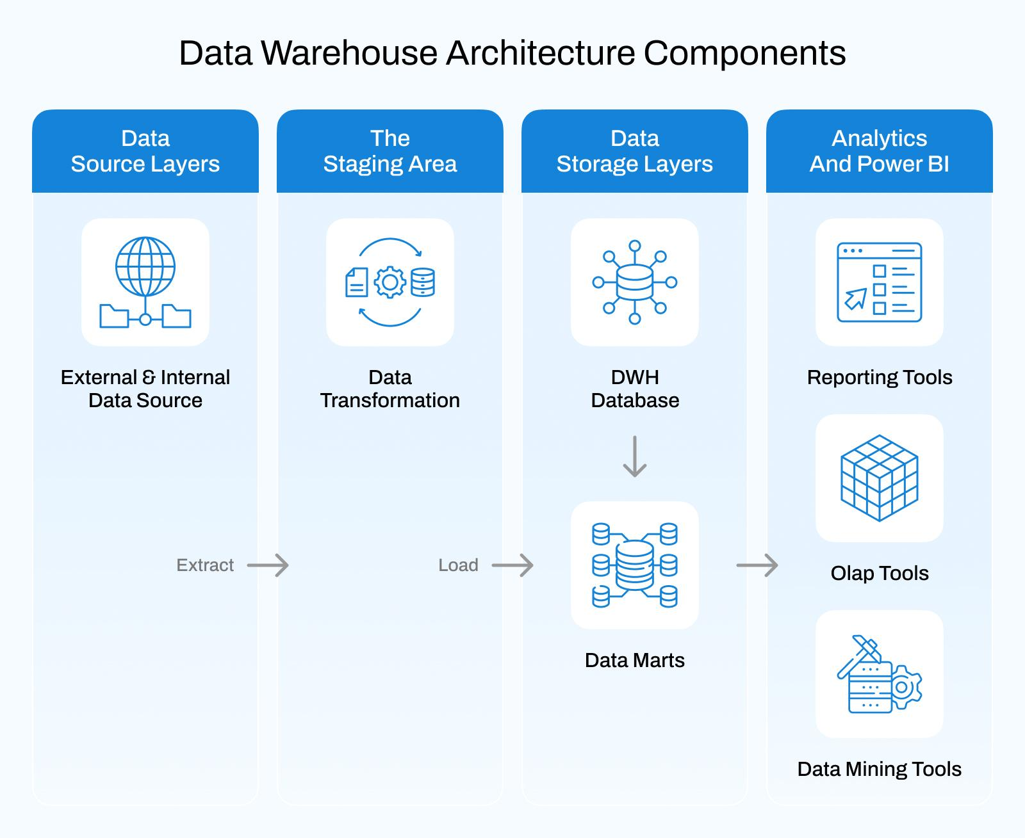

Definition
A Data Warehouse stores historical data collected from multiple sources for reporting and analytics.

Characteristics
- Structured data only
- Optimized for analytical queries
- Supports business intelligence and reporting
- Stores historical records

Examples
- Snowflake
- Amazon Redshift
- Google BigQuery
- Azure Synapse Analytics

Use Cases
- Dashboard Reporting
- Business Intelligence
- Trend Analysis

3. Data Lake

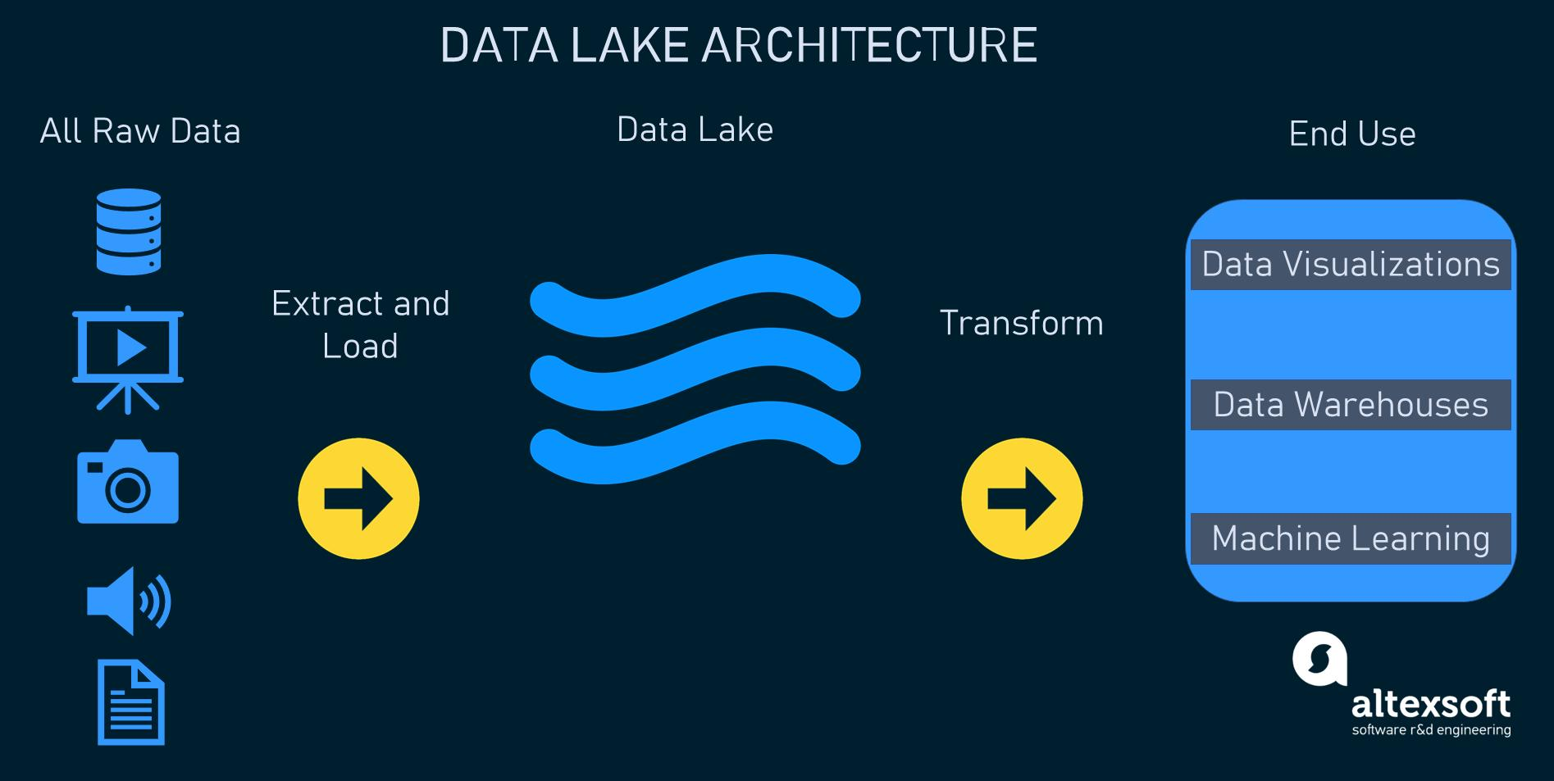

Definition
A Data Lake stores large amounts of raw data in its original format.

Characteristics
- Stores structured, semi-structured, and unstructured data
- Low-cost storage
- Highly scalable
- Schema-on-Read approach

Data Types
- CSV Files
- JSON Files
- Images
- Videos
- Log Files
- Sensor Data

Examples
- Azure Data Lake Storage
- Amazon S3
- Google Cloud Storage

Limitations
- No ACID transactions
- Data duplication
- Poor data quality
- Difficult data governance

4. Delta Lake

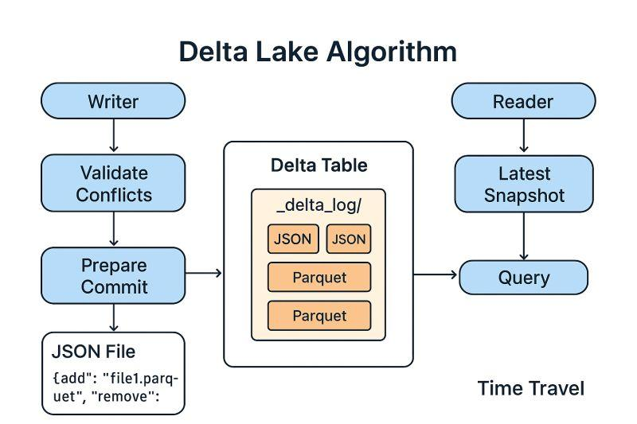

Definition
Delta Lake is a storage layer that adds reliability, performance, and transaction support to a Data Lake.

Characteristics
- Supports ACID Transactions
- Schema Enforcement
- Time Travel
- Data Versioning
- Batch and Streaming Processing

Advantages
- Prevents data corruption
- Improves query performance
- Maintains data consistency
- Enables rollback to previous versions

Key Features of Delta Lake

1. ACID Transactions
Ensures reliable data operations.

Example
Multiple users can update the same table without causing data corruption.

2. Schema Enforcement
Prevents incorrect data from being inserted.

Example
If a column expects Integer values and String data is inserted, Delta Lake throws an error.

3. Time Travel
Allows access to previous versions of data.

Example
SELECT * FROM sales VERSION AS OF 2;

4. Data Updates
UPDATE sales
SET amount = 5000
WHERE order_id = 101;

5. Data Deletion
DELETE FROM sales
WHERE order_id = 101;

6. Merge (Upsert)
MERGE INTO sales s
USING updates u
ON s.order_id = u.order_id
WHEN MATCHED THEN
UPDATE SET *
WHEN NOT MATCHED THEN
INSERT *;

Why Databricks Uses Delta Lake
Databricks uses Delta Lake because it provides:
- Reliable Data Storage
- ACID Transactions
- Better Query Performance
- Data Versioning
- Machine Learning Support
- Streaming and Batch Processing
- Scalability for Big Data

